Tensile Testing Lab Report
[Name]
Saginaw Valley State University
Department of Mechanical Engineering
Principles of Engineering Materials Laboratory (ME250L)
PROCEDURE
One 7075 Aluminium specimen that was cold worked and two 7075 aluminium that were heat treated by annealing them in air for three hours at 415 °C. Literature data of the mechanical properties; tensile strength, yield strength and ductility of the specimens was derived from the textbox’s appendix. The data was used to generate functions of engineering stress against engineering strain.
Drawbacks
The tensile test machine is very expensive, with its price being not less than $10000. Furthermore the machine is susceptible to failure in case of overload.
Before the tensile test was done, the load cell rated maximum capacity was checked so as not to overload the system. The highest tensile strength that the machine could tolerate was calculated by dividing the cross-sectional area of the gage length of the test specimen.
A spreadsheet containing time, load, crossarm extension and extensometer displacement was created based on the tensile test data generated by the loading cell machines software. This data was used to generate experimental graphs of engineering stress and strain. Comparisons of the experimental data and literature data were made. Also differences between the extensometer displacement and crossarm displacement were studied.
The following formulas were used to generate additional data;
P = load
A_{o} = initial cross-sectional area of the specimen
s = engineering stress = P / A_{o}
L_{o} = gauge length measured on the specimen (4 inches)
∆ L = crossarm extension
e₁ = engineering strain measured from the crossarm displacement = ∆ L / L_{o}
L₂₀ = extensometer knife edge separation before tensile test (2 inches)
L₂ = extensometer knife edge separation at any time during the tensile test
e₂ = engineering strain measured from the extensometer = (L₂ - L₂₀) / L₂₀
True stress and strain were also calculated.
A = instantaneous cross-sectional area of the specimen
σ = true stress = P/A = s (e2 + 1)
ε ₁ = true strain measured by crossarm displacement = ln [(∆ L + L₀)/L₀] = ln (e₁ + 1)
ε ₂ = true strain measured by extensometer = ln (L₂/L₂₀) = ln (e₂ + 1)
The test was done in four phases. The first specimen, cold worked 7075 aluminium, was loaded to failure and the results labeled as sample1. The second specimen annealed aluminium was loaded to failure.in the third test, annealed 7075 aluminium specimen was work harden by loading it above its yield point. This was referred to as sample 3. The specimen was then loaded again but to failure. This was sample4. The results from the four tests were used to generate graphs and values of young’s modulus yield strength, ultimate strength, stress and strain were obtained.

RESULTS AND DISCUSSIONS
Results from the cold worked 7075 aluminium which was loaded to failure are in the table below.
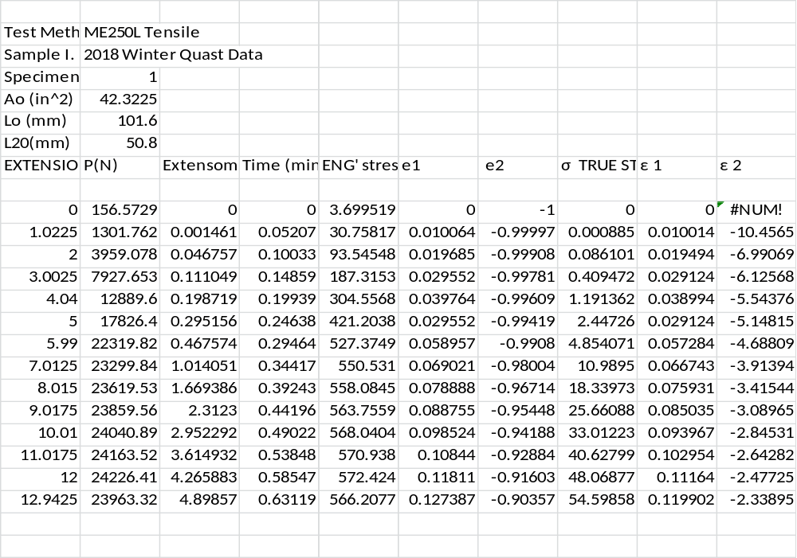
Table 1 sample 1 results
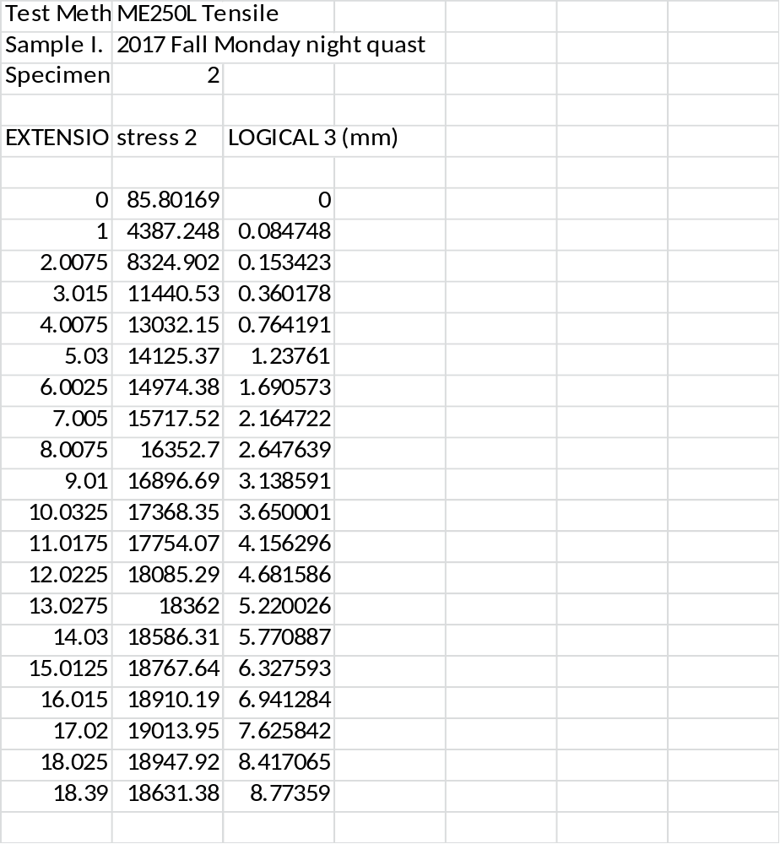
Table 2 sample 2 results
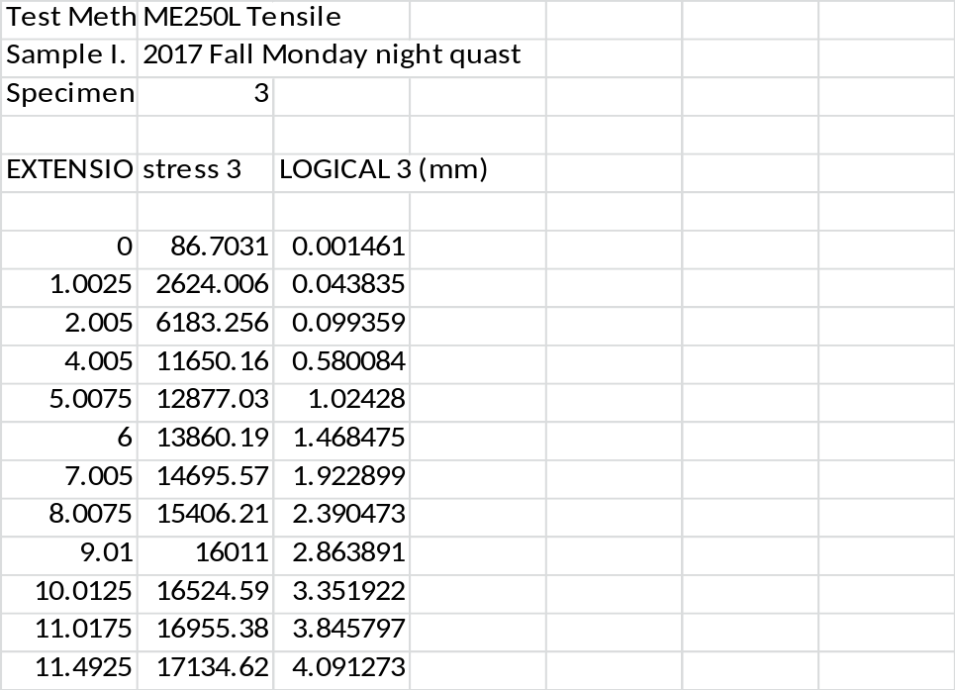
Table 3 sample 3 results
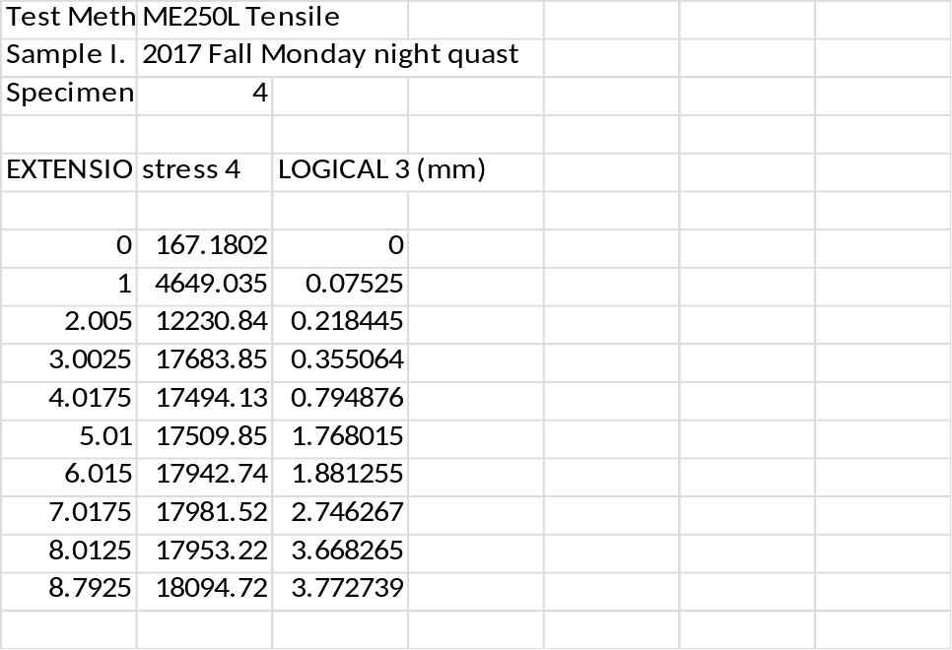
Table 4 sample 4 results

Figure 1 strain verse stress for sample 1 and sample2
The above is a plot of two curves: σ as a function ε 2 for sample1 and sample2.Cold worked aluminium has lower yield strength compared to annealed samples. However annealed aluminium has superior strain hardening qualities. The fact that annealing involves heating the material under considerably high temperatures, a uniform lattice is formed as it cools thus minimizing the internal stress and cracks. Therefore it has higher yield strength and higher strain-to-fracture ratio due to minimized internal stresses. It also can withstand higher ultimate load.

Figure 2 true stress verses true strain
Sample 4 offers the highest yield strength in comparison to the other specimen. This is because majorly annealed aluminum 7075 specimen was work hardened (sample 3) before the final experiment. This increased its yield strength at the expense of its strain hardening strength. Sample 3 offers higher yield strength as compared to sample 2 as well as strain hardening.
Meanwhile sample3 exhibited higher ultimate strength and strain-to-failure in comparison to the other samples. This is due to the fact that it does not undergo any prior loading therefore there are minimal internal stress within the sample.

Figure 3 stress and trues stress verse strain graph
The true stress being a function of engineering stress, the two graphs do not cross at zero. The two stresses are proportional to each other.
.
Figure 4 strain verse engineering stress of sample 1
Young’s modulus (crossarm displacement);
$$E=\frac{stress}{strain}=slope=\frac{2376-399.4}{0.01949-0.01001}=208GPa$$
Young” modulus (extensometer displacement);
$$E=\frac{stress}{strain}=slope=\frac{2376-399.4}{-3.2347+3.9056}=2.9GPa$$
Cross arm displacement, e1 gives a more accurate value than the extensometer. Extensometer takes a recording of the average displacement. This explains why its values are less compared to cross arm displacement method. In addition, calibration of the extensometer is rather difficult.
The literature values differ from the experimental data values. This is because experimental data is inclusive of the defects within the specimen while the literature data assumes the specimen has zero defects. These defects mainly occur during the manufacturing process.
CONCLUSION
Finite element software was used to conduct a test on four pieces of aluminimu 7075 and determine their stress-strain relationships. Graphs from the data generated by the machine were used to plot graphs which aided in analyzing the mechanical properties of the specimens. Careful recording and reading of measurement and good calibrated gauges can reduce errors in the experiment.
EXPERIMENTAL ERRORS
Errors in the results from the data obtained could be due to faulty loading machine, machine flexes, measurement recording errors and calibration errors.

REFERENCES
Hambli, R., Reszka, M., 2002. Fracture criteria identification using an inverse technique method and blanking experiment. International Journal of Mechanical Sciences 44, 1349-1361.
Hoa, V.C., Seo, D.W., Lim, J.K., 2005. Site of ductile fracture initiation in cold forging: a finite element model. Theoretical and Applied Fracture Mechanics 44, 58-69.
Jain, M., J. Allin, J., D. J. Lloyd, D.J., 1999. Fracture limit prediction using ductile fracture criteria for forming of an automotive aluminum sheet. International Journal of Mechanical Sciences 41, 1273-1288.
Komori, K., 2005. Ductile fracture criteria for simulating shear by node separation method. Theoretical and Applied Fracture Mechanics 43, 101–114.
Weng, T.L., Sun, C.T., 2000. A study of fracture criteria for ductile materials. Engineering Failure Analysis 7, 101-125.
Yang, X., Chen, C., Hu, Y., Wang, C., 2005. Damage analysis and fracture criteria for piezoelectric ceramics. International Journal of Non-Linear Mechanics 40, 1204 -1213.

